CM3070 - Final project
By David Della Rossa

Project Design

Overview

Template
Arcade Game - Game development

Fightship Arena is a fast-action manic shooter game, where the player fights in a closed arena against hordes of hostile spaceships, in a time match, managing the weapon arsenal in real-time and building complex tactics against enemies.

The intention is to create a game in the Bullet Hell, fast-action arena-based genre, with some elements of tactics in how to manage weapons and power-ups during the gameplay.

Its main features can be summarised as:

- Fast-action arena-based game
- Fight against hordes of various types of hostile fightships in a time match
- Develop your tactics, managing your weapon arsenal in real-time
- Expand your fightship's arsenal with a wide set of power-ups

The game will offer three different modalities:

Harvester Mode
Make the highest possible score with one life.
Game goes on until the player dies.
The player is rewarded with time-bonus-score-multipliers at predefined time-checkpoints.

Punisher Mode
Defeat all enemies. The number of enemies is pre-set at the beginning of the level.
They spawn in waves, triggered by the game status.
The number and composition of enemy waves is predefined for each level.
During gameplay, the player can see the number of enemies left to defeat.

Highlander Mode
Stay alive until the time is over. Here, the constant is the time.
The number of enemy waves spawning is variable and depends on the game status.
If score/time is beyond a pre-set threshold, more time can be given. This is considered as normal match time, therefore, if the player dies during this phase, the match is lost.

If score/time is beyond another set threshold, extra time can be given to reach an even higher score. This is considered as extra time, and starts after the normal time is over and the player has won the match. If the player dies during this phase, the match ends, but the player is still the winner.

Design and Architecture

Rules
Single player versus game

NPCs:
All characters will be differentiated by:
- How tough they are to defeat;
- How fast they move;
- Which weapons they are equipped with;
- Which power-ups they leave behind when destroyed;

Enemy: Pawn
Spawn in high numbers and head to the player's fightship, with the intent of colliding with it and destroying it.

They can be dangerous as they move in high numbers towards the player from different directions with the intent of surrounding it.
A variant of type 1 is able to scatter around when shot by the player, trying to dodge player's shots.

Enemy: Infantry
Spawn in moderate numbers and stand where they are, floating around and shooting at the player's.

Not too dangerous per-se. They can become insidious when the player is dealing with other enemies, as they keep shooting.

Enemy: Shielder
Spawn in small groups. They are equipped with a protective shield and are able to proceed like a roman testudo formation, protecting other enemies behind them, while moving towards the player.
If the formation is damaged, they rearrange closing ranks.
If alone, they proceed towards the player with kamikaze intent. Other enemies can follow along, protected by their shield.

Enemy: Turret
Equipped with a short range plasma-beam weapon which can damage the player and slow it down in its movements, if it comes too close.
They float around in the arena. If two turrets come in short range, they can form an energy wall where the player cannot pass through and which stops the player's bullets. Destroying one turret would destroy the wall.

Weapons
Player starts with only one/two weapons, plus a limited quantity of Serious bombs and Protective shield, but can acquire more during the gameplay.
Ammunition and energy are left in the arena by some enemies on destruction, but in each arena there is an area where the player can go and have certain weapons and energy recharged.

Multi-cannon
Fires a continuous stream of energy bullets. The shape of the stream and the number of bullets fired in the unit of time changes based on the power-ups collected. Player starts with a double multi-cannon (two streams of bullets).
Ammunition is provided collecting Energy charger power-ups.

Fire-flow
Fires a continuous fire beam. If the fire-flow hits certain objects or certain types of enemies, it keeps flowing all around those objects.
Ammunition is provided collecting Fire-flow Ammunition power-ups.

Rocket-launcher
Pressing the fire button, launches one single rocket; releasing the fire button the rocket explodes, damaging all enemies around. This is useful to destroy enemies behind a protective shield.
Ammunition is provided collecting Rocket launcher Ammunition power-ups.

Plasma-wiper
Pressing the fire button, this weapon fires at the closest enemy to the player and from there it spreads to other enemies around. After a short time, all the enemies touched by the plasma-beam explode in a blast that can damage other enemies around even though they were not touched by the plasma-wiper's beam. During the plasma-beam action, all enemies touched by it are slowed down.
Ammunition is provided collecting Plasma-Beam charger power-ups.

Serious bomb
This weapon is capable of completely clearing up the screen from all enemies.
Occasionally extra Serious bomb ammunition power-ups are spawn in certain levels.

Protective shield
Enables a protective shield all around the player's fightship that stops enemy weapons and pushes enemies away on contact.
There is a maximum amount of seconds per level allowed for the Protective shield. This varies from level to level.

Power-ups

Score multiplier
The initial score multiplier for the player's score is 1.
Each score multiplier powerup increases the total score multiplier, applied to the score gained from each enemy destroyed, by a certain factor.

Energy charger
Increases the energy level by a certain amount.

Fire-flow charger
Increases the amount of Fire-flow ammunition by a certain amount.

Plasma-Beam charger
Increases the amount of Plasma-Beam ammunition by a certain amount.

Rocket Ammunition
Increases the amount of Rocket ammunition by a certain amount.

Serious bomb
Add one Serious bomb to the player’s arsenal

Protective shield charger
Increases the Protective shield by a certain amount.

Technologies in use
Game Engine/Editor: Unity3D

Targeted platforms are:
- Windows 10
- WebGL

Work plan
You will find the Gantt diagram here.

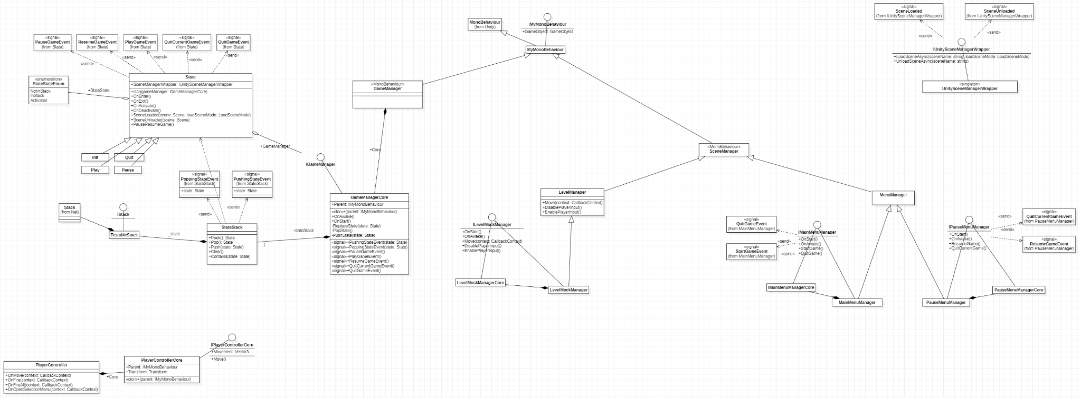
Class diagram of the implementation up to now.

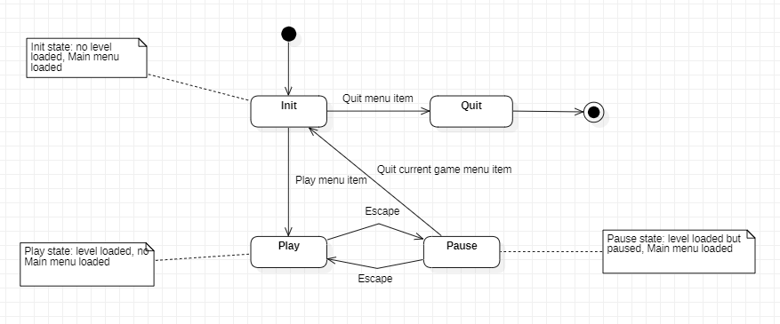
State machine for the GameManager.

Test plan
In the second part of the course, after the Mid-Term deadline, I plan to create a build of the game and ask for a few fellow students, or colleagues to voluntarily offer to test the game.
I plan to produce three versions of the game during the second part of the project.
The testers will do their evaluation purely on a voluntary basis. No form of remuneration will be given.
When they are ready to provide their feedback, a brief questionnaire will be provided, where they can share their thoughts and ideas on improvements, or notify bugs or any type of malfunctioning.
This feedback will then be evaluated and the proper actions will be taken to put tester’s suggestions in the game’s next version.

Further information
For further information about the game design, please see the github wiki.
For further information about the project management, please see the github project.
For further information about the source code, please see the github repository.
For further information about the game architecture, please see the UML diagram (it requires StarUML).
For the Gantt diagram, please see here.
Note: all these links point to resources which are all Work-In-Progress. The Information therein contained can therefore change at any moment without any type of notice, until the project deadline.

Serious bomb is borrowed from Serious Sam game franchise - Croteam 2001-2020

